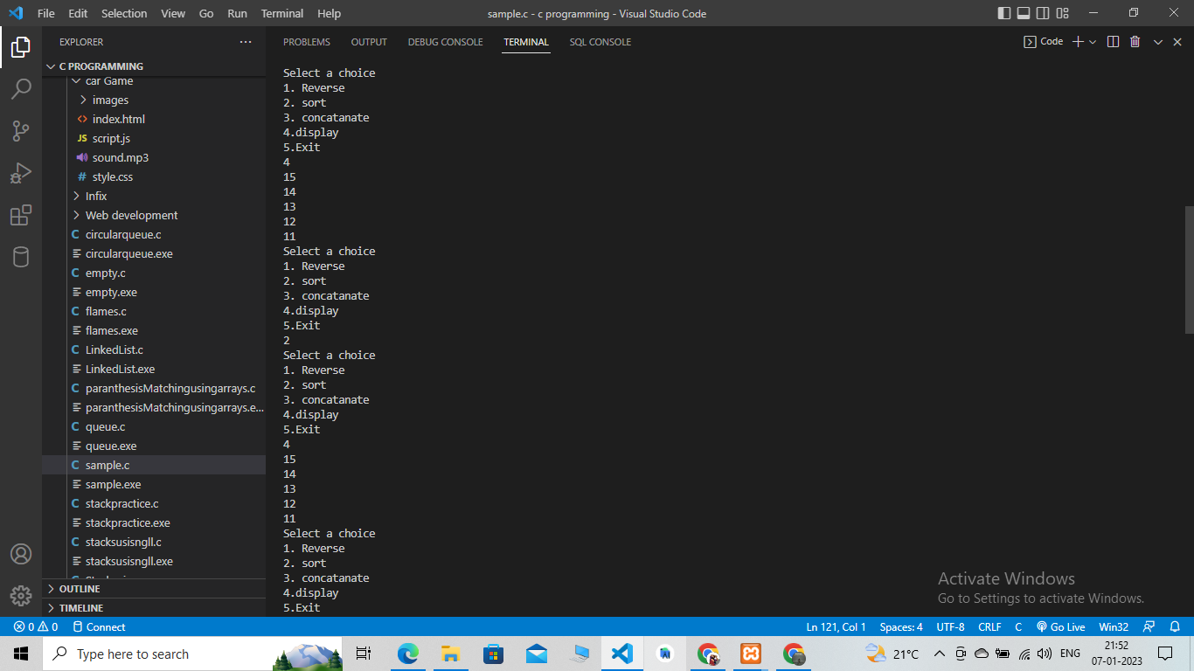

#include <stdio.h>

#include <stdlib.h>

typedef struct node

{

int data;

struct node\* next;

} node;

node\* head;

void reverse();

void sort(node\*);

void createLinkedList();

void concatanate(node\*, node\*);

void display(node\*);

int main(){

int opt;

createLinkedList(5);

node\* heada = head;

display(heada);

while(opt != 5){

printf("Select a choice\n1. Reverse\n2. sort\n3. concatanate\n4.display\n5.Exit\n");

scanf("%d", &opt);

switch(opt){

case 1: reverse();

heada = head;

break;

case 2: sort(heada);

break;

case 3:

createLinkedList(4);

node\* headb = head;

concatanate(heada, headb);

break;

case 4: display(heada);

break;

}

}

return 0;

}

void createLinkedList(int n){

node\* temp;

for (int i = 0; i < n; i++){

if(i == 0){

temp = (node\*)malloc(sizeof(node));

head = temp;

}

else{

temp->next =(node\*) malloc(sizeof(node));

temp = temp->next;

}

printf("Enter the data\n");

scanf("%d", &temp->data);

}

temp->next = NULL;

}

void concatanate(node\* heada, node\* headb){

node\* temp = heada;

while(temp->next!= NULL){

temp = temp-> next ;

}

temp->next = headb;

}

void reverse(){

node\* prev = head;

node\* pres = prev->next;

prev->next = NULL;

node\* temp;

while(temp->next!= NULL){

temp = pres->next;

pres->next = prev;

prev = pres;

pres = temp;

}

temp->next = prev;

head = pres;

// display

temp = head;

while(temp != NULL){

printf("%d\n", temp->data);

temp = temp->next;

}

}

void sort(node\* heada){

// node\* prev = heada;

node\* temp1 = heada;

int c;

while(temp1->next != NULL){

node\* temp2 = temp1->next;

while (temp2 != NULL){

if(temp2->data > temp1->data){

c = temp1->data;

temp1->data = temp2->data;

temp2->data = c;

}

temp2 = temp2->next;

}

temp1 = temp1-> next;

}

}

void display(node\* heada){

node\* temp = heada;

while(temp!= NULL){

printf("%d\n", temp->data);

temp = temp->next;

}

}